# 

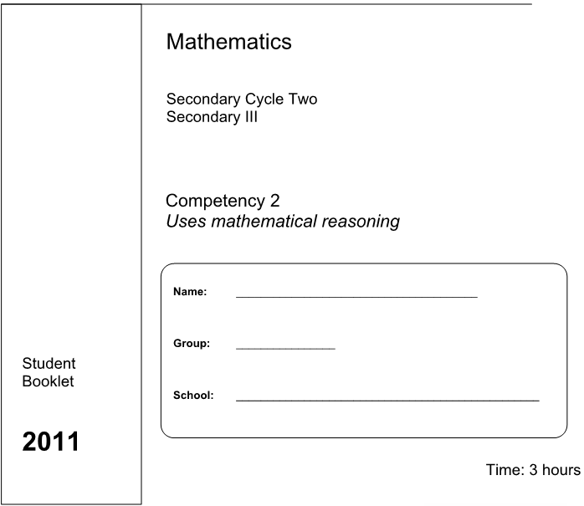

February

2015

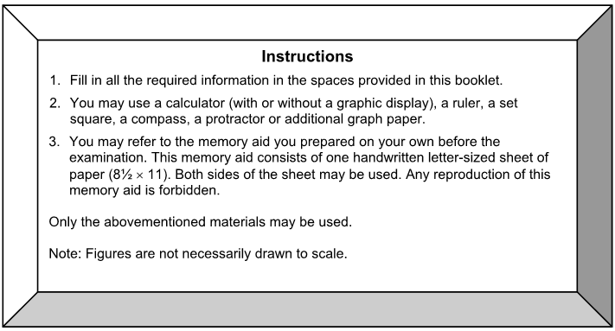

**Instructions**

1. Fill in all the required information in the spaces provided in this booklet.
2. You may use a calculator, a ruler, a set square, a compass, a protractor, or additional graph paper.
3. You may refer to the memory aid you prepared on your own before the examination. This memory aid consists of one handwritten letter-sized sheet of paper (8½” x 11”) . One side of the sheet may be used. Any reproduction of this memory aid is forbidden.

Only the abovementioned materials may be used.

Note: Figures are not necessarily drawn to scale.

**PART A – MULTIPLE CHOICE**

**Note:** Each question is worth 4 marks and there are no part marks. Ensure your answers are recorded on the answer sheet on **page 7**.

1. Ten identical cubes are shown below in oblique perspective.

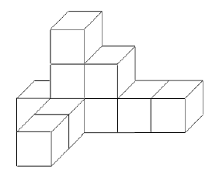

Which of the following images best represents this object viewed from the right side?

|  |  |  |  |
| --- | --- | --- | --- |
| A) |  | C) |  |
| B) |  | D) |  |

2. Which of the following expresses the number 0.000 000 025 in scientific notation?

|  |  |  |  |
| --- | --- | --- | --- |
| A) | 25 × 109 | C) | 2.5 × 108 |
| B) | 2.5 × 10-8 | D) | 25 × 10-9 |

3. What is the value of f(3) given f(x) = 4x2 - 10?

|  |  |  |  |
| --- | --- | --- | --- |
| A) | f(3) = 3 | C) | f(3) = 132 |
| B) | f(3) = 12 | D) | f(3) = 26 |

4. Which expression is NOT equal to 4x5?

|  |  |  |  |
| --- | --- | --- | --- |
| A) | 6x5 – 5x5 – (-3x5) | C) | 2x2 + 2x3 |
| B) | (2x)4  4x-1 | D) | (2x6)(x-3)(2x2) |

5. Kassidy charges $6.50 per hour plus a fixed cost for gas money to babysit at her aunt’s house in Shawville every Wednesday. This week she earned $53.50 for seven hours of work.

**How much does Kassidy charge for gas money?**

|  |  |  |  |
| --- | --- | --- | --- |
| A) | $0 | C) | $7.64 |
| B) | $8.00 | D) | $45 |

6. Consider the inequality below:

3(-2x + 5) > 2x + 47

**Which of the following number lines best represents the solution to the inequality?**



A) C)



B) D)

**PART B – SHORT ANSWER**

**Note:** Part marks may be awarded. Ensure answers are recorded on **Page 7**. Each question is worth 4 marks.

7. **Expand and/or simplify the following expressions.**

1. (4a + 5b) – (2a – 3b) C) (5x + 3)(2x – 1)
2. D)

8. The graph below shows the price of a bus ticket in dollars (y) as a function of the number of people going on the trip (x).

y

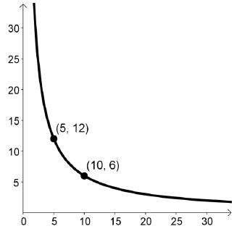

Price of ticket ($)

x

Number of people on the trip

**What is the price of a bus ticket if 15 people go on the trip?**

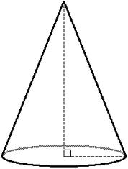9. The diagram below shows a cone with a slant height of 10 cm, and a base with a diameter of 16 cm.

10 cm

16 cm

**What is the total surface area of the cone?**

10. The Ottawa Food Fest charges a flat admission price, plus a fee for every sample. Kassidy tried 5 samples, and she paid $34.50 in total. Olivia tried 8 samples, and she paid $48 in total.

**If Finn tried only 3 samples, how much did Finn pay in total?**

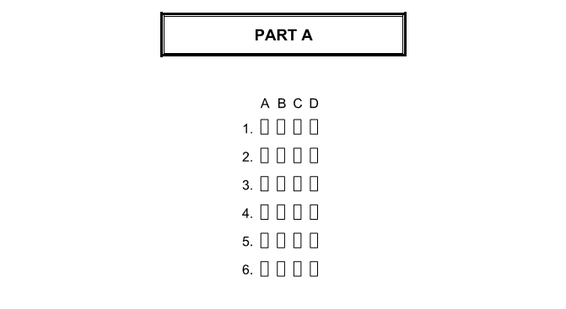

|  |  |
| --- | --- |
| 7. | *Write the simplified expressions in the space provided. (1 mark each)* [0] [1] [2] [3] [4]   1. ________________________ C) ___________________________ 2. ________________________ D) ___________________________ |
| 8. | The price of a ticket is $__________________________. [0] [4] |
| 9. | The cone’s total surface area is ____________ cm2. |

10. Finn paid $__________ in total.

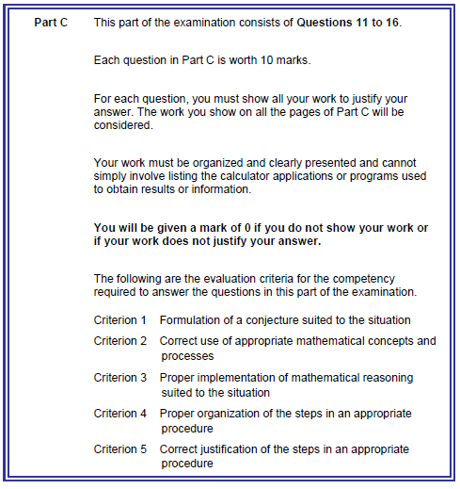

**11. Faster Than a Horse**

Sir Runsalot boasts that he can outrun a horse in a race.

Both the horse and Sir Runsalot start their race a certain distance away from the same rock, however Sir Runsalot gives the horse a head start.

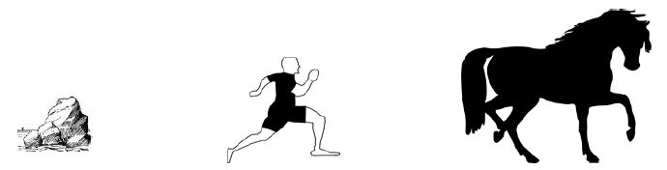After 5 seconds Sir Runsalot is 40 m from the rock.

After 12 seconds Sir Runsalot is 89 m from the rock.

The horse’s distance from the rock vs time is shown in the graph below.

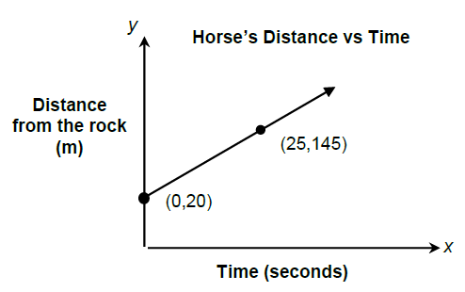

**When does Sir Runsalot catch up to the horse?**

**How far is he from the rock?**

**Show all your work.**

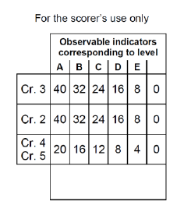

**Sir Runsalot catches up to the horse at _____ seconds, at a distance of ______ m from the rock.**

**12. The Play Tent**

Tara is making a canvas play-tent for her daughter Olivia. It is a hollow square-based prism with a roof that is shaped like a square-based pyramid. Olivia has to be able to get inside, so the front of the square-based prism is open, but the rest of the sides are covered by canvas including the bottom.

The side length of the base of the prism is 100 cm and the height of the prism is 60 cm. The height of the pyramid is 120 cm. (Diagram is not drawn to scale.)

**What is the total area of canvas required to make the play-tent?**

60 cm

120 cm

100 cm



**The area of canvas required is __________________ cm2.**

**13. Chico’s Sporting Goods**

Anne and Ben are employees at Chico’s Sporting Goods.

Anne works in the shoe department and gets paid $8.50 per pair of shoes plus an additional $80.

Ben works in the hockey department and gets paid a fixed amount for every pair of skates he sells, plus a base salary.

The table below shows Ben’s earnings as a function of the number of skates he sells.

**Ben’s Earnings Based on the # of Skates Sold**

|  |  |
| --- | --- |
| **# of Pairs of**  **Skates Sold** | **Money Earned**  **($)** |
| 3 | 101.50 |
| 9 | 176.50 |
| 12 | 214.00 |

One day, Anne earned $216. That same day, Ben sold 4 more pairs of skates than the number of pairs of shoes Anne sold.

**How much money did Ben earn that day?**

**Show all work.**



**Ben earned $ _______________ that day.**

**14. Patio Planning**

Will and Steve, two neighbours, are both putting in new brick patios. Both patios have the same perimeter.

2x + 2

6x - 4

4x - 1

x + 8

2x

x + 1

5x -3

3x + 3

5x -3

7x - 2

**Steve’s patio**

**Will’s patio**

To save on costs Steve and Will paid for a single delivery of 500m2 of bricks. All leftover brick will be used to build a walkway.

**What is the total area of the brick that is left over for the walkway?**

**Show all work.**



**The is ______________ m2 of brick left over to construct a walkway.**

**15. New Hockey Gear**

Bryson is budgeting to pay for some new equipment and registration fees for next year’s hockey season. He wants a new composite hockey stick, skates, hockey pants, and of course he has to pay for tournament fees.

His budget is as follows: he can spend four times as much on skates as he can on pants. The stick costs $25 more than double the price of the hockey pants. The tournament fees will cost $100 less than triple the cost of the skates. The most he can spend on the season is $1350.

**Bryson found a top-of-the-line pair of Bauer skates on sale, in his size, for $350. Should he buy them? Justify / explain your reason, and show all work.**



**Should Bryson buy the $350 skates? (circle one)**

**YES NO**

**Justification:**

**16. A Friend for Olaf**

Anna and Elsa are building a new snowman, and they’re deciding between two shapes for the snowman’s head: a sphere with radius *r*, and a cylinder with the same radius but half the height of the sphere.

Elsa is showing off, and she claims that the surface area of this sphere must be the same as the surface area of the cylinder. Anna thinks that this is impossible.

**Who is correct? Use at least three examples to draw your conclusion, and write a full sentence answer. Credit will not be given without full justification.**

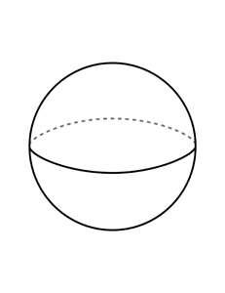

r

r

**Who is right? (Circle one)**

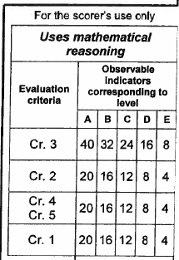

**Elsa Anna**

**Justification:**