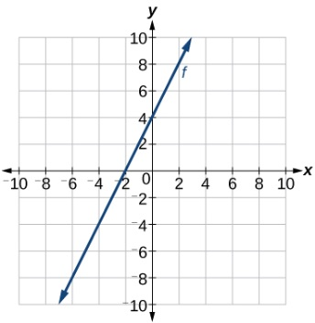  - Calculate the slope (a)  - Identify the y-intercept b from the graph  - Write in form y = ax +b | Example:  a = $\frac{y2-y1}{x2-x1}$ = $\frac{rise}{run}$ = $\frac{4}{2}$ = 2  b = 4  y = ax +b  Equation is y = 2x +4
Find the equation of a line passing through the points (2, 3) and (6, 4)  - Calculate the slope (a)  - Identify the y-intercept b using b = y - ax  - Write in form y = ax +b | Example:  a = $\frac{y2-y1}{x2-x1}$ = $\frac{4-3}{6-2}$ = $\frac{1}{4}$ = 0.25  b = y – ax  b = 4 – (0.25)(6)  b = 4 – 1.5  b = 2.5  Equation is y = 0.25x + 2.5
x y  0 70  1 90  2 110  3 130  - Calculate the slope (a)  - Identify the y-intercept b using b = y - ax  - Write in form y = ax +b | Example:  a = $\frac{y2-y1}{x2-x1}$ = $\frac{110-90}{2-1}$ = $\frac{20}{1}$ = 20  b = y – ax  b = 90 – 20(1)  b = 90 – 20  b = 70  Equation is y = 20x +70

Graph

Coordinates

Table of Values

